

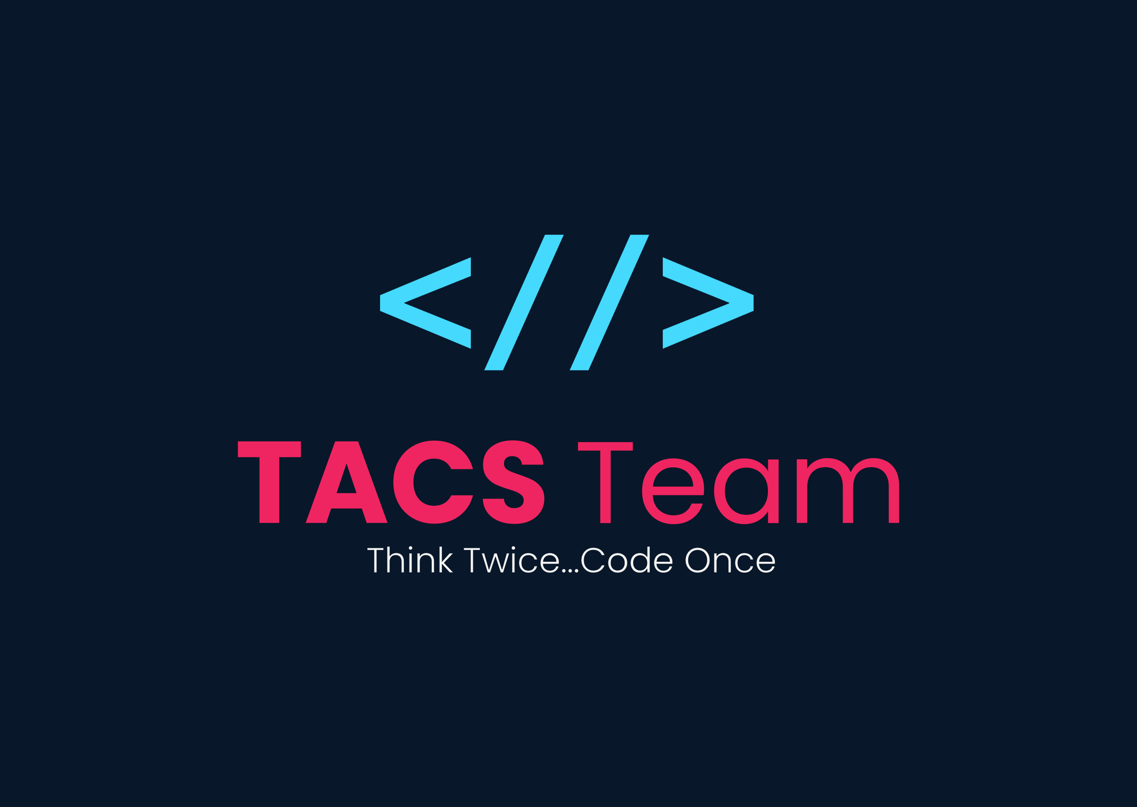

College System

**DR/ Mahmmoud Mahdi**

**Powered BY TACS Team**

**Name: Ali Abdulsalam Elshorpagi.**

**ID:** **20912021100013.**

**Section:17.**

**Name: Ammar Gamal Gouda.**

**ID: 20912021100558.**

**Section: 17.**

**Name: Amr Sameh Mohamed.**

**ID:** **20912021100652.**

**Section: 18.**

**Name: Mohamed Said Ibrahim**

**ID:** **20912021100716.**

**Section:21.**

**Overview**

College System is a basic software for managing College Data, such as Courses, Staff, Student...etc. All of these functions are handled by the system using files as a temporary database. these files are used to store and print data.

Note: You can see this project on GitHub ^_^

Link: https://github.com/Ali-Elshorpagi/College_System

# Diagrams

## Class Diagram

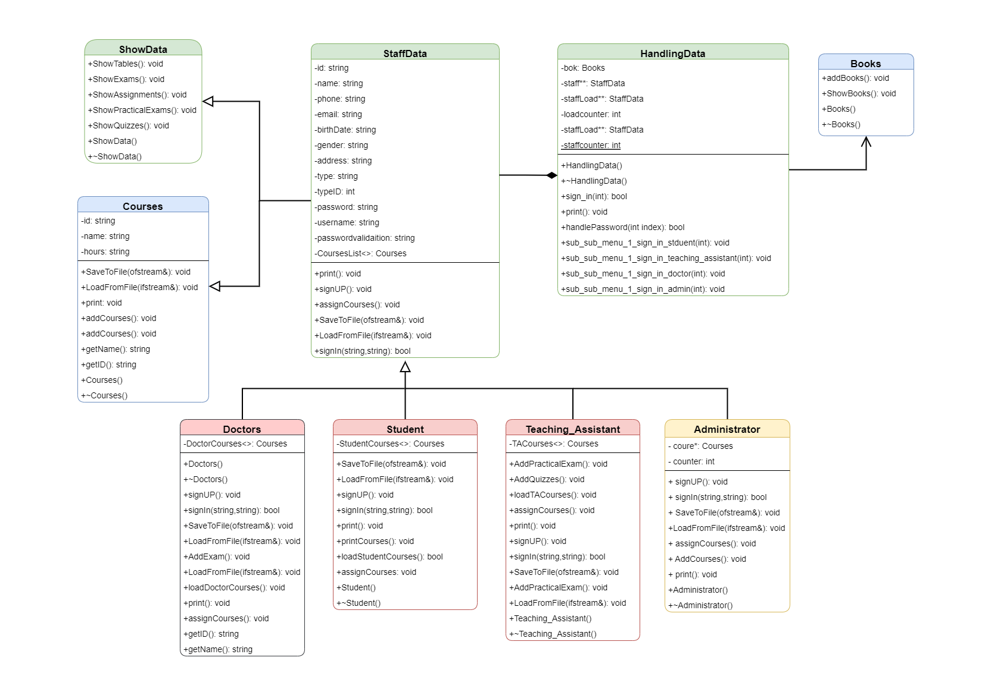

## Flow Diagram

**Classes & Functions**

1. Class Administrator

|  |  |  |
| --- | --- | --- |
|  | Function Name | Description |
| 1 | virtual void signUP(); | This function Is used to sign up for Adminstartor |
| 2 | virtual bool signIn(string,string); | This function is used to sign in for Adminstartor |
| 3 | void SaveToFile(ofstream&); | This function is used to save Adminstartor information to files |
| 4 | void LoadFromFile(ifstream&); | This function is used to Load Adminstartor information from files. |
| 5 | void AddCourses() | This function is used to add courses . |

**2.**Class StaffData

|  |  |  |
| --- | --- | --- |
|  | Function Name | Description |
| 1 | virtual void assignCourses()=0; | This function is pure virtual function because it will be overridden on derived classes. |
| 2 | virtual void SaveToFile(ofstream&)=0; | This function is pure virtual function because it will be overridden on derived classes and used for save data to files. |
| 3 | virtual void LoadFromFile(ifstream&)=0; | This function is pure virtual function because it will be overridden on derived classes and used for load data from files.. |
| 4 | virtual bool signIn(string,string) = 0; | This function is pure virtual function because it will be overridden on derived classes and used for sign in for Students or Doctors ….etc. |
| 5 | virtual void signUP() = 0; | This function is pure virtual function because it will be overridden on derived classes and used for sign up for Students or Doctors ….etc. |
| 6 | virtual void print()=0; | This function is pure virtual function because it will be overridden on derived classes and used for print information . |

**3.**Class Doctor

|  |  |  |
| --- | --- | --- |
|  | Function Name | Description |
| 1 | virtual void signUP(); | This function is used for sign up for doctors |
| 2 | virtual bool signIn(string,string); | This function is used for sign in for doctors |
| 3 | void SaveToFile(ofstream&); | This function is used Save Doctor Information to files |
| 4 | void LoadFromFile(ifstream&); | This function is used Load Doctor Information From files |
| 5 | void AddExam(); | This function is ued to load Exams from files |
| 6 | void AddAssignments(); | This function is used to load Assignments from file |

**4.**Class Student

|  |  |  |
| --- | --- | --- |
|  | Function Name | Description |
| 1 | void SaveToFile(ofstream&); | This function is used to save Student to Files. |
| 2 | void LoadFromFile(ifstream&); | This function is used to Load Student From Files. |
| 3 | void signUP(); | This function is used for sign up for Studetns |
| 4 | bool signIn(string,string); | This function is used for sign in for Studetns |
| 5 | void assignCourses(); | This function is used to assign Student to Courses |
| 6 | bool loadStudentCourses(); | This function is used to load Student Courses from Files |

**5.**Class Teaching_Assistant

|  |  |  |
| --- | --- | --- |
|  | Function Name | Description |
| 1 | virtual void signUP(); | This function is used for sign up for Teaching_Assistant |
| 2 | virtual bool signIn(string,string); | This function is used for sign in for Teaching_Assistant |
| 3 | void SaveToFile(ofstream&); | This function is used for Save Teaching_Assistant Information to files |
| 4 | void LoadFromFile(ifstream&); | This function is used for Load Teaching_Assistant Information From files |
| 5 | void AddPracticalExam(); | This function is used for Load Practical Exams From files |
| 6 | void AddQuizzes(); | This function is used for Load Quizzes From files |

**6.**Class Books

|  |  |  |
| --- | --- | --- |
|  | Function Name | Description |
| 1 | void addBooks(); | This function is used for AddBooks |
| 2 | void ShowBooks(); | This function is used for Load Book From Files |

**7.**Class Courses

|  |  |  |
| --- | --- | --- |
|  | Function Name | Description |
| 1 | void SaveToFile(ofstream&); | This function is used for Save Couses Information to files |
| 2 | void LoadFromFile(ifstream&); | This function is used for Load Couses Information From files |
| 3 | void addCourses(); | This function is used for add courses user must enter Course code,name and hours. |
| 4 | void print(); | This function is used for print Courses information |

**8.**Class ShowData

|  |  |  |
| --- | --- | --- |
|  | Function Name | Description |
| 1 | void ShowTables(); | This function is used for load tables from files. |
| 2 | void ShowExams(); | This function is used for load Exams from files. |
| 3 | void ShowAssignments(); | This function is used for load Assignments from files. |
| 4 | void ShowPracticalExams(); | This Function Is used for load Practical Exams From Files |
| 5 | void ShowQuizzes(); | This function is used for load Quizzes From Files. |

**9.**Class HandlingData

|  |  |  |
| --- | --- | --- |
|  | Function Name | Description |
| 1 | bool sign_in(int); | This function Function is used sign in for Doctor,student,Teaching Assistan and Adminstrator. |
| 2 | void sign_up(int); | This function Function is used sign UP for Doctor,student,Teaching Assistan and Adminstrator. |
| 3 | void sub_sub_menu_1_sign_in_stduent(int); | This function is used for Handling sign in menu for student. |
| 4 | void sub_sub_menu_1_sign_in_teaching_assistant(int); | This function is used for Handling sign in menu for Teaching assistant. |
| 5 | void sub_sub_menu_1_sign_in_doctor(int); | This function is used for Handling sign in menu for Doctor |
| 6 | void sub_sub_menu_1_sign_in_admin(int); | This function is used for Handling sign in menu for admin. |

**Demo**

1. Scenario Case:
   1. **Sign Up**
      1. **Doctor**
      2. **Student**
      3. **Teaching Assistant**
      4. **Administrator**
   2. **Sign In**
      1. **Doctor**
      2. **Student**
      3. **Teaching Assistant**
      4. **Administrator**